**GUJARAT UNIVERSITY**



**PROJECT REPORT ON**

**K12 education.**

**SCHOOL MANAGEMENT SYSTEM**

**DEVELOPED BY:**

**MAHI PRAJAPATI (202126940096)**

**BANSARI PATEL (202126940077)**

**AAROHI SHAH (202126940111)**

**Msc.IT DATA MANAGEMENT & VISUAL INSIGHT (Semester 3)**

**Department Of Animation, GUJARAT UNIVERSITY**

**Academic Year (2022-2023)**

**Internal Guide: Ms. Neepa Mandalia**

**Acknowledgement**

* School Management System helps headmasters to get the most accurate information to make more effective decisions.
* Teachers and headmasters gain time saving administrative tools, Parents gain immediate access to their children’s grades and students can track their own progress.
* School Management System equipped features makes it possible to generate schedules and reports in minutes and to retrieve attendance records, grade checks, report cards, transcripts, and form letters in just a few clicks.
* School Management System helps teachers to complete grade book, Track students attendance, input class notes, create lesson plans And detailed reports, and communicate with other staff members, Students , and parents all via e-mail.
* It also helps students to access assignments and tests, and view Attendance records, grades, report cards, and progress reports all online. They also can communicate through mail and forms with teachers and other students online.
* My School (SMS) is a web enabled application developed in PHP and Powerful MYSQL database backend. To implement My School Application, schools do not need expensive hardware and software They just need an internet connection and desktops.
* Our system Works as a centralized database and application that schools can easily access the system from anywhere based on the login Credentials.
* My school is a platform independent system that Virtually any user can access from anywhere through a standard Internet accessible system.
* We can also customize My school for Individual school needs.

**Table Of Content**

|  |  |  |
| --- | --- | --- |
| NUMBER | DESCRIPTION | PAGE NO |
| 1 | Introduction |  |
|  | 1.1 Project Summary |  |
|  | 1.2 Purpose |  |
|  | 1.3 project Scope |  |
|  | 1.4 Tools and Technology |  |
| 2 | System Planning |  |
| 3 | Feasibility Study |  |
| 4 | System Design |  |
|  | 4.1 DFD |  |
|  | 4.2 Database Design(Data Dictionary) |  |
|  | 4.3 Screen Layout |  |
| 5 | Testing |  |
|  | 5.1 Test Cases |  |
| 6 | Conclusion |  |
| 7 | Future Enhancement |  |
| 8 | References and Bibliography |  |

**1.INTRODUCTION**

* Nowadays education plays a great role in development of any country.
* Many of education organizations try to increase education quality.
* One of the aspects of this improvement is managing of school resources
* Our system is a major tool through this managing process by making a continuous communication between headmaster, teacher, parents and student. So in order to achieve that goal, we need a Website that covers the needs of all users at the same time.
* For Students, they can view their subject's grades, contact with the headmaster and teachers for any complaint, recommendation or an absence permission, and they also up to date with all school's news or posts that publish by the other users.
* For Headmasters, they have a full control on the systems, like they can add a new parents, teachers and students with their subjects.
* For Teachers, they can add student’s grades or edit it for their own subjects only, and they have a direct connection with students and their parents.
* For Parents, they have an access for their sons/daughters grades without any possibility to edit on it, and they can directly contact with teachers and headmasters.
* All the system users can publish whatever they need within the educational process on the last updates section, and these posts is visible for all the users.

**1.1 PROJECT SUMMARY**

* The academic achievement for many students has decline, because of lake of care of them from their parents, and this refer to that their parents do not have a free time to come to school .
* Headmasters and Teachers are facing problems at the start of every new academic year, because of distribution process for courses and classes, in addition to this , through and at the end of every year another problem is facing them, which is the complexities of the grades entry process for their students .
* Lack of communication after a school day between Headmasters, Teachers, Parents and Students, which has a bad reflection on the educational process.

**1.2 PURPOSE**

* The present education structure is radical, open and more practical.
* The days are gone when school and colleges were loaded with files and other paper-based record books.
* Thanks to the school management system software that completes arrays of tasks including the student’s fee, the teacher’s salary, attendance register, timetables for all classes, fee records, examination records and results of the exams within no time.
* There are many reasons why an increasing number of schools are using school management software on regular basis.
* Best school software helps a school communicate in an effective way with the parents.
* The school management find easy in sharing information and circulating. All the communication relevant tasks are done in short span of time and more effectively.
* Parents can check result of their child online. Undoubtedly, this software has strengthened the participation and communication of parents with school
* Most of the ERP solutions for schools are integrated with online payment gateway.
* Parents find flexibility in paying school fee online through their dashboard. This eliminated the parent’s queues at school or banks for fee payment.
* Parents find convenience to pay school fees online using their debit card, credit card or NET banking sitting in any corner of the world.

**1.3 PROJECT SCOPE**

* Same thing for some parents where they do not prefer that way for the My School has been designed to provide an easy way for Palestinian students - in Gaza Strip - to get their grades, and for their parents to be familiar with that grades and the academic achievement for their kids.
* However this project is facing some obstacles which is deny it from achievement it’s goals, like . lack of acceptance these idea from some teachers and headmasters, because of their poor knowledge about using that technology or they find that using computers in their works instead of the paper works so hard and difficult. And also the same previous reasons.

**TOOLS AND TECHNOLOGY**



**HTML:**

* Is the standard markup language used to create web pages. Web browsers can read HTML files and render them into visible or audible web pages. HTML elements form the building blocks of all websites.
* HTML allows images and objects to be embedded and can be used to create interactive forms.
* It provides a means to create structured documents by denoting structural semantics for text such as headings, paragraphs, lists, links, quotes and other items.



**CSS:**

* Is a Web page derived from multiple sources with a defined order of precedence where the definitions of any style element conflict.
* The Cascading Style Sheet, level 1recommendation from the World Wide Web Consortium (W3C), which is implemented in the latest versions of the Netscape and Microsoft Web browsers, specifies the possible style sheets or statements that may determine how a given element is presented in a Web 9 page.
* And describes how HTML elements are to be displayed on screen, paper, or in other media.



**PHP:**

* Is an open source server-side language which is used for creating dynamic web pages ,

It can be embedded into HTML.

* PHP is usually used in conjunction With a MySQL database on Linux/UNIX web servers. It is probably the most popular scripting language.
* And it is a widely-used general-purpose scripting language and interpreter that is freely available. A full explanation of all the PHP tags.



**MySQL Database:**

* MySQL is the world's most popular open source database.
* With its proven performance, reliability and ease-of-use, MySQL has become the leading database choice for web-based applications, used by high profile web properties including Facebook, Twitter, YouTube, Yahoo! and many more .

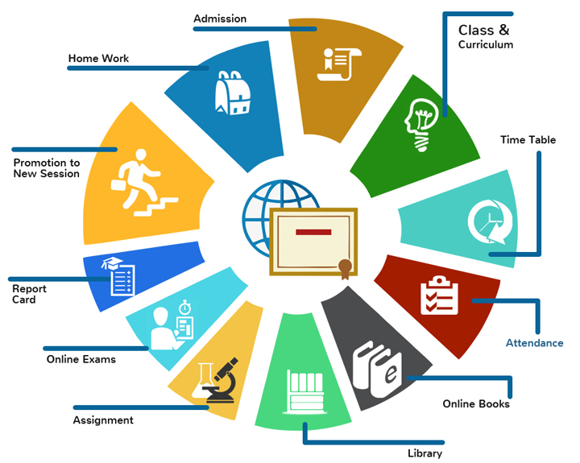

**TOOL:**

School Tool is a cloud-based open-source school administration software made for schools in the developing world.

**2. SYSTEM PLANNING**

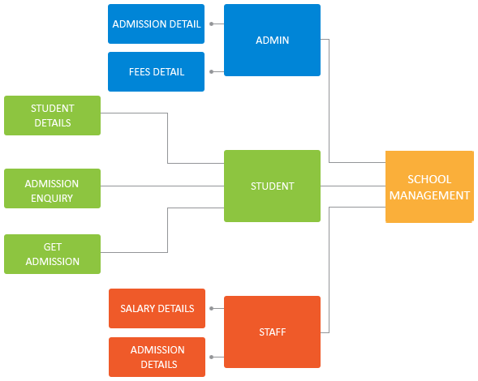

**3. FEASIBIITY STUDY**

**4. SYSTEM DESIGN**

**4.1 DFD**

* School Management System Data flow diagram is often used as a preliminary step to create an overview of the school without going into great detail, which can later be elaborated.
* It normally consists of overall application data flow and processes of the school process.
* It contains all of the user flow and their entities such all the flow of Students, Class, Teachers, Timetable, Fees, Attendance, Subjects.
* All of the below diagrams has been used for the visualization of data processing and structured design of the school process and working flow.

**0 Level Diagram**

* This is the Zero Level DFD of School Management System, where we have elaborated the high level process of school.
* It’s a basic overview of the whole School Management System or process being analyzed or modeled.
* It’s designed to be an at-a-glance view of Log in, Registration, Inquiry form and Feedback form showing the system as a single high-level process.
* We have described the high level flow of the school System.

* High Level Entities and process flow of School Management System:
* Managing all the Students
* Managing all the class
* Managing all the Teachers
* Managing all the Timetable
* Managing all the Fees
* Managing all the Attendance
* Managing all the Subjects

Admission Management

Admission Management

Classes

Management

Fees Management

Student Management

Fees Management

Student Management

Fees Management

Student

Management

Fees

Management

Faculty Management

System User Management

Faculty Management

System User Management

Faculty

Management

System User

Management

Login Management

Login Management

Login

Management

Zero Level DFD – School Management System

Zero Level DFD – School Management System

**1st Level Diagram**

* First Level DFD of School Management System shows how the system is divided into sub-systems, each of which deals with one or more of the data flows to or form an external agent, and which together provide all of the functionality of the School Management System as a whole.
* It also identities internal data stores of Subjects, Attendance, Fees, Timetable, Teachers that must be present in order for the School system to do its job, and shows the flow of data between the various parts of Students, Teachers, Attendance, Subjects, Fees of the system.
* Main entities and output of First Level DFD (1st Level DFD):
* Processing Students records and generate report of all Students.
* Processing Class records and generate report of all class.
* Processing Teachers records and generate report of all Teachers.
* Processing Timetable records and generate report of all Fees.
* Processing Attendance records and generate report of all Attendance.
* Processing Subjects records and generate report of all Subjects.

Generate Student Report

Student Management

Generate Student Report

Student Management

Generate Faculty Report

Faculty Management

Faculty Management

Generate Classes Report

Generate Classes Report

Classes Management

Classes Management

Generate Fees Report

Fees Management

Generate Fees Report

Fees Management

Check User Login Details

Check User Login Details

Login Management

Login Management

System User Management

Generate System User Report

Generate System User Report

System User Management

First Level DFD – School Management System

**4.2 Database Design**

|  |  |  |  |  |  |
| --- | --- | --- | --- | --- | --- |
| **Field Name** | **Data Type** | **Date Format** | **Field Size** | **Description** | **Example** |
| Student ID | Text | XNNNNNNN | 8 | Unique identification for each student | 51234567 |
| First_ Name | Text |  | 20 | Student’s First Name | Conner |
| Last_ Name | Text |  | 20 | Student’s Surname | Thomas |
| Year_ Group | Number | ## | 2 | Year level the student is in | 8 |
| Date_ Of_ Birth | Date/Time | DD/MM/YYYY | 10 | Date the student was born | 14/08/2005 |
| Student_ Image | Image | .jpg | --- | Profile photo of the student | --- |
| School_ Team | Text |  | 10 | Coloured team student assigned | Blue |

**4.3 Screen Layout**

**Login Page**

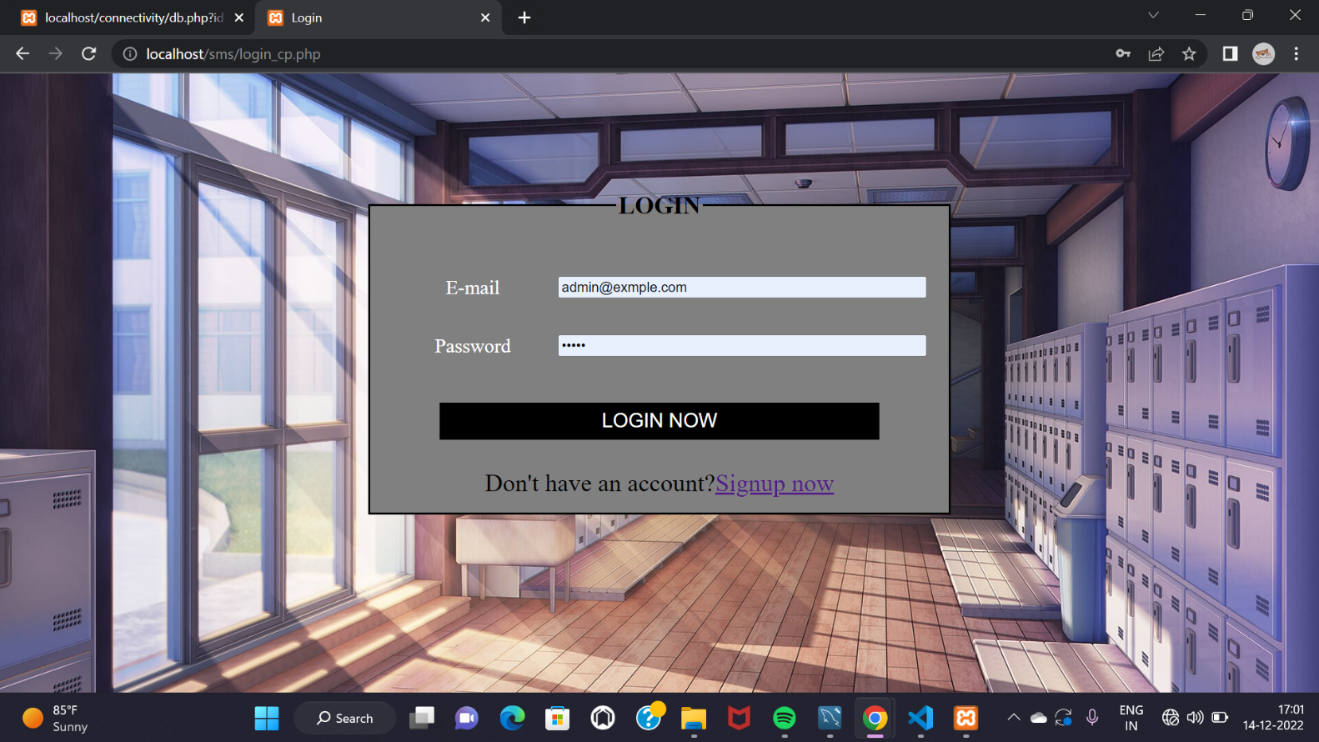

**Registration Page**

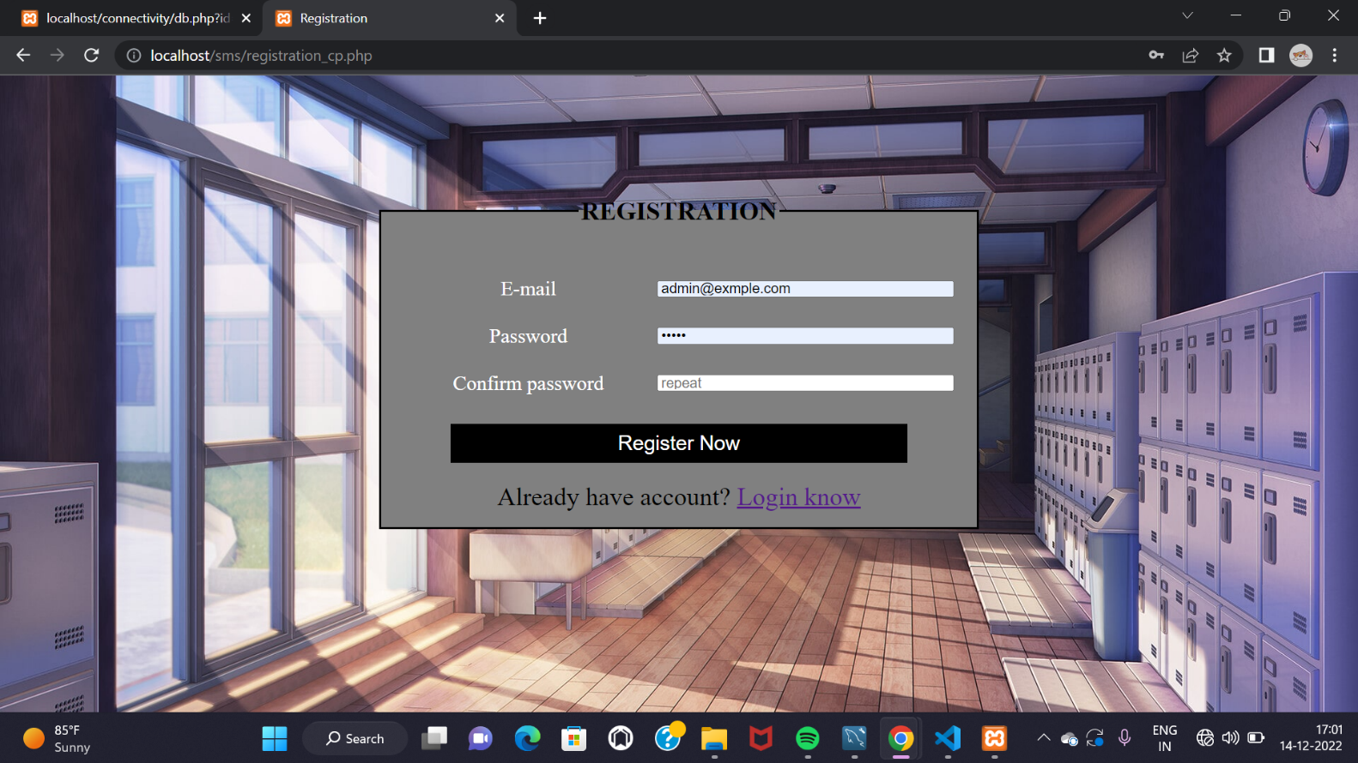

**Home Page**

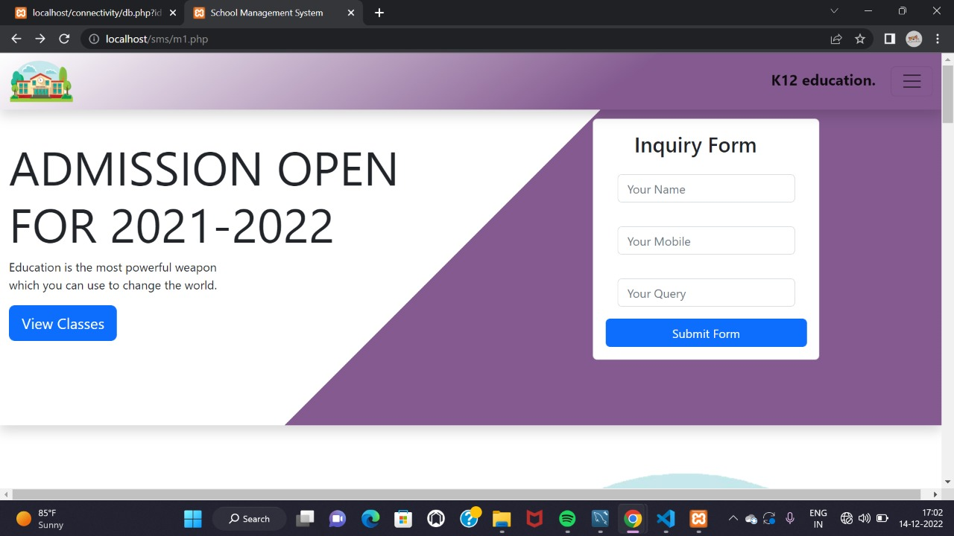

**Home Page**

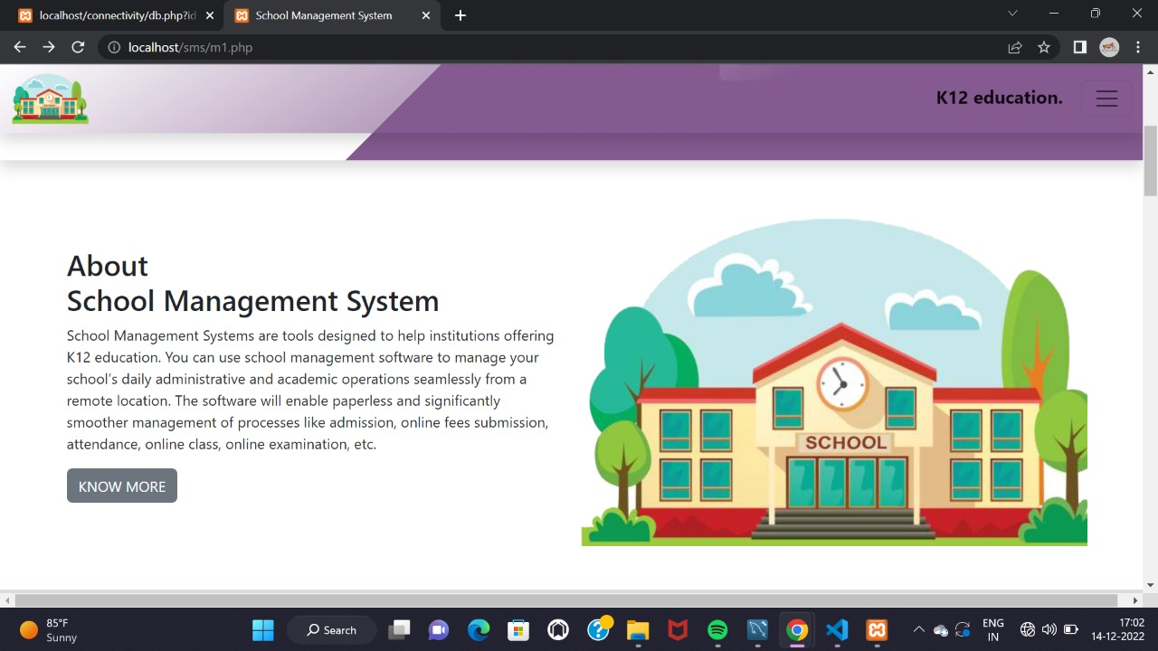

**Home Page**

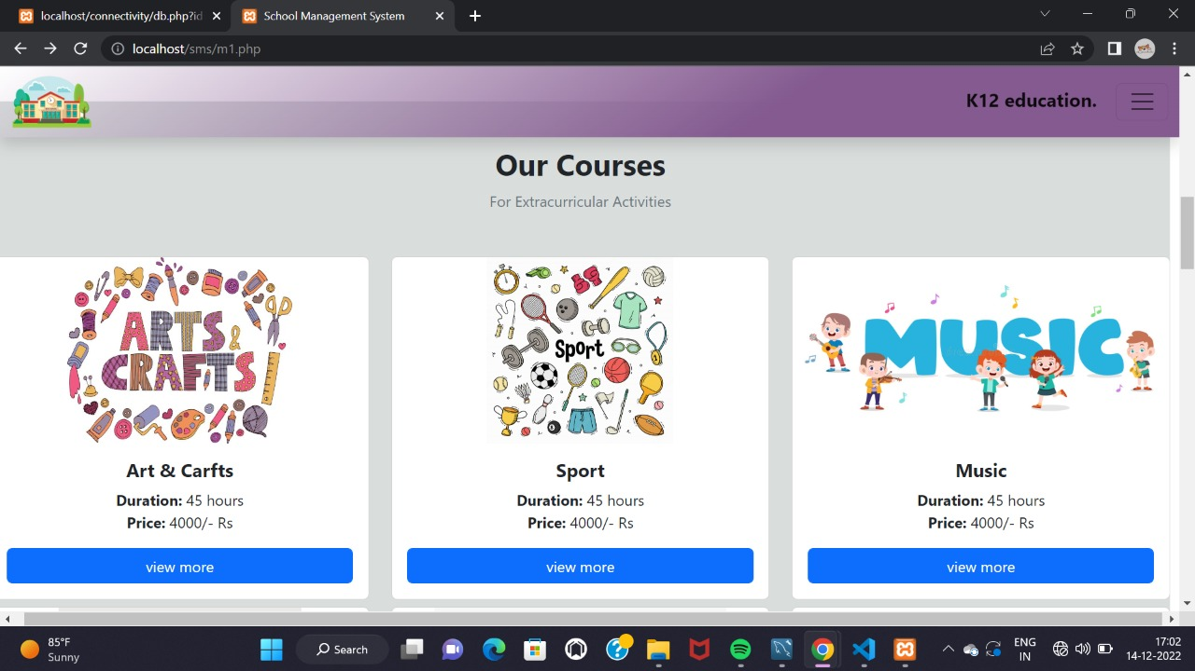

**Home Page**

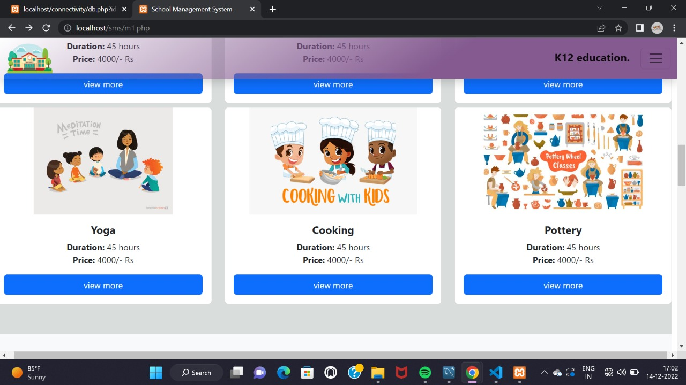

**Home Page**

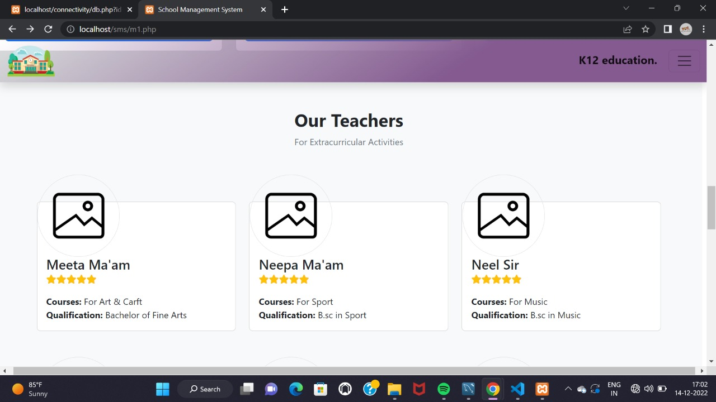

**Home Page**

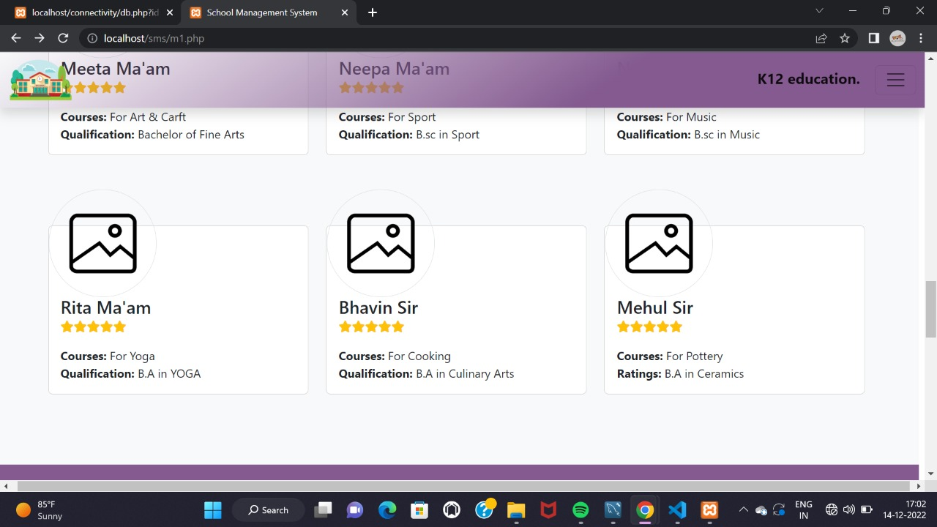

**Home Page**

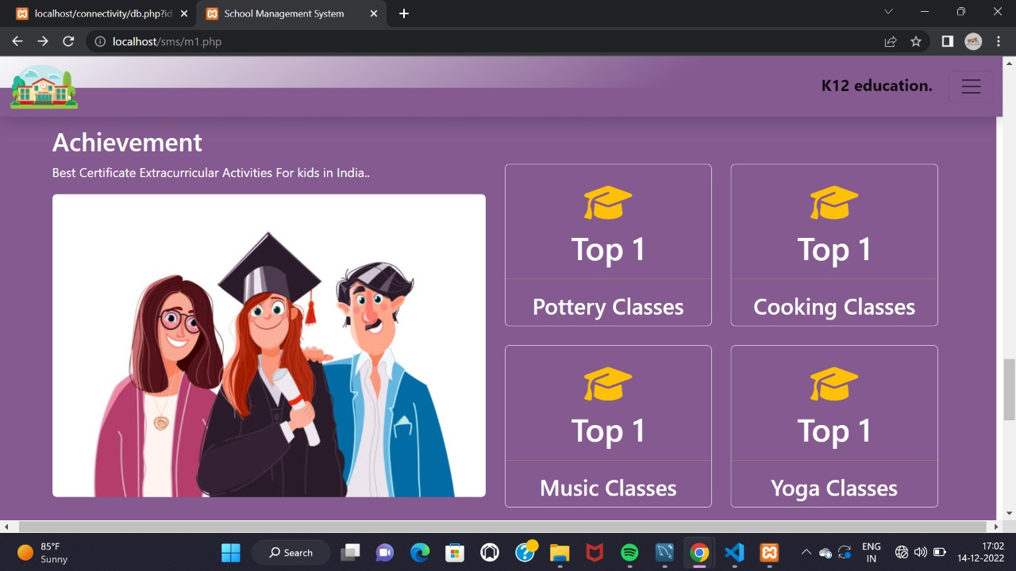

**Home Page**

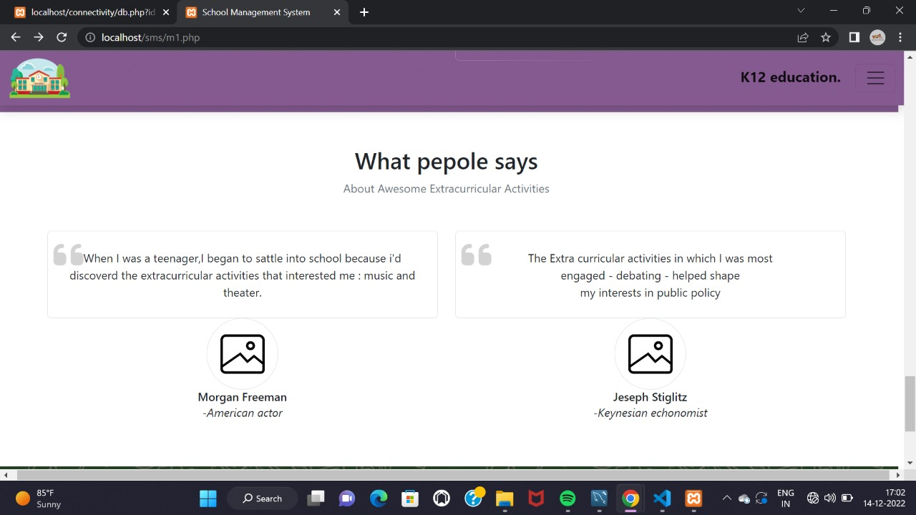

**Home Page**

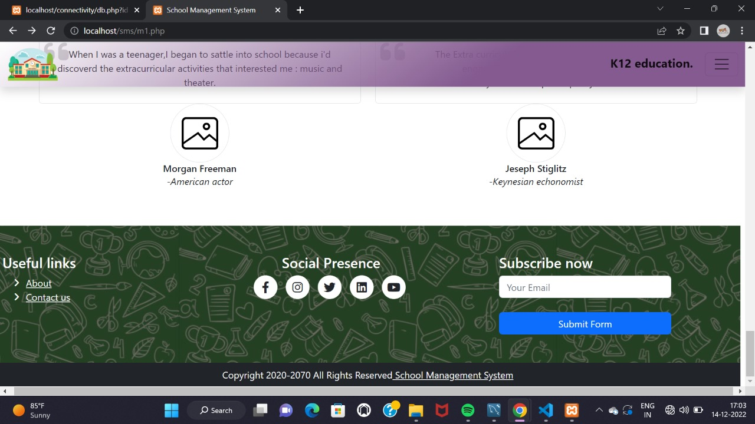

**2nd Home Page**

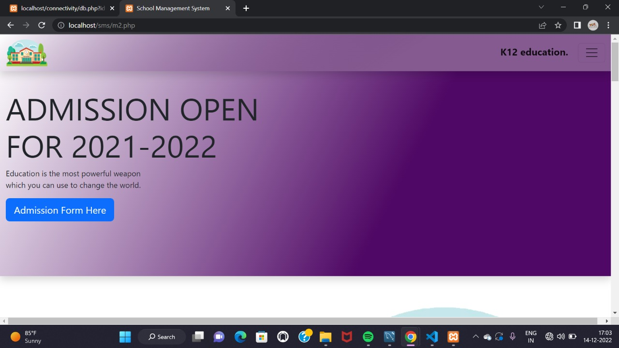

**2nd Home Page**

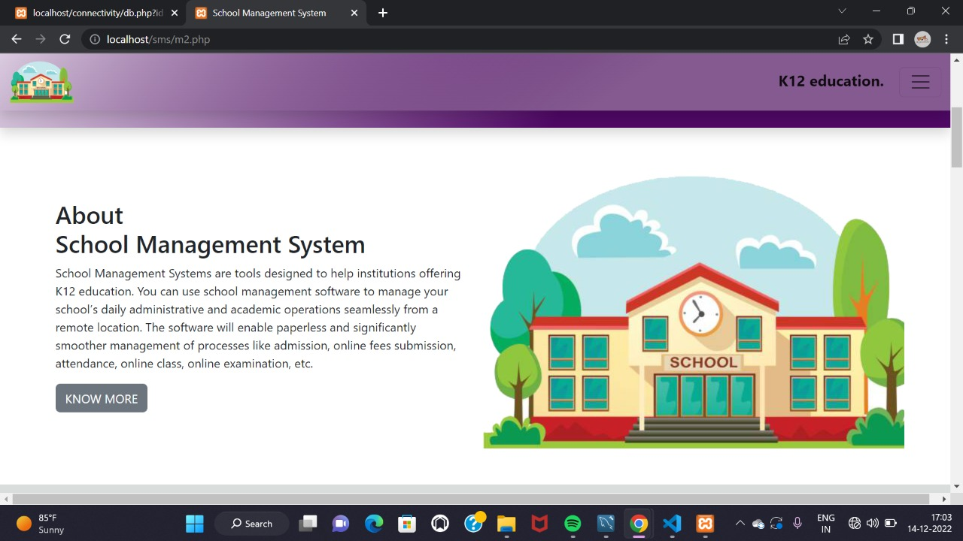

**2nd Home Page**

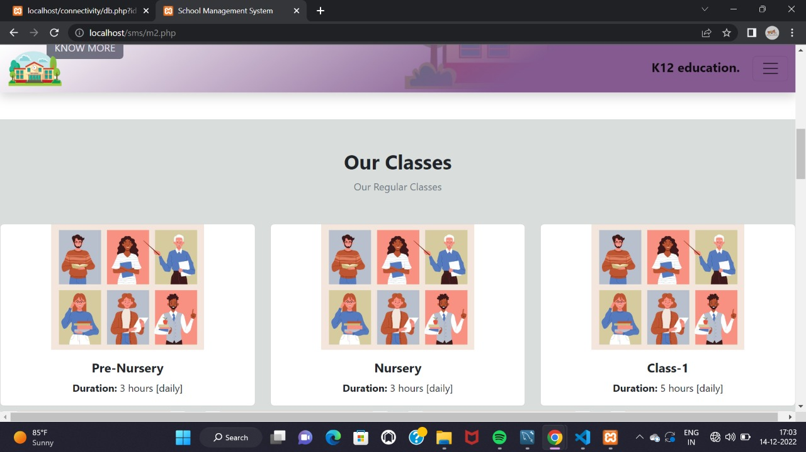

**2nd Home Page**

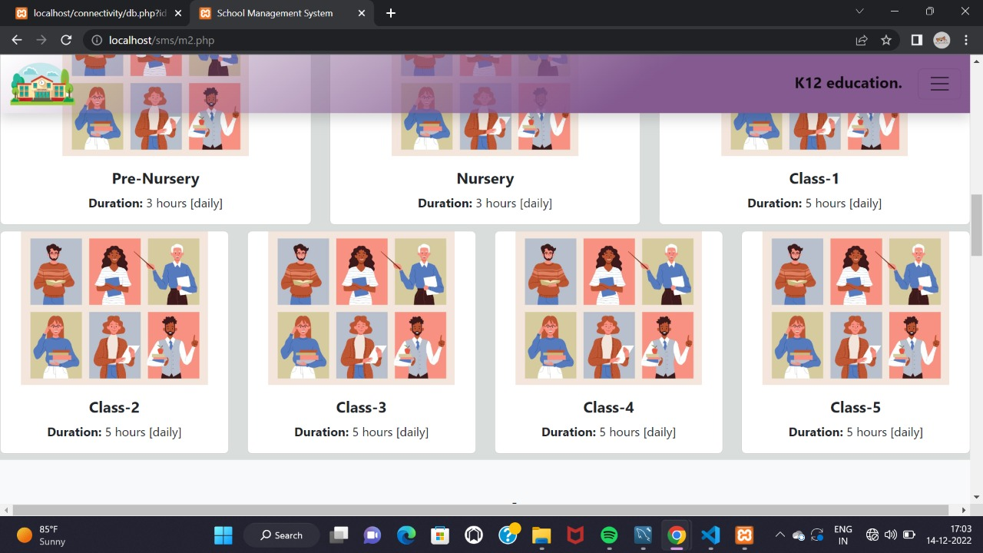

**2nd Home Page**

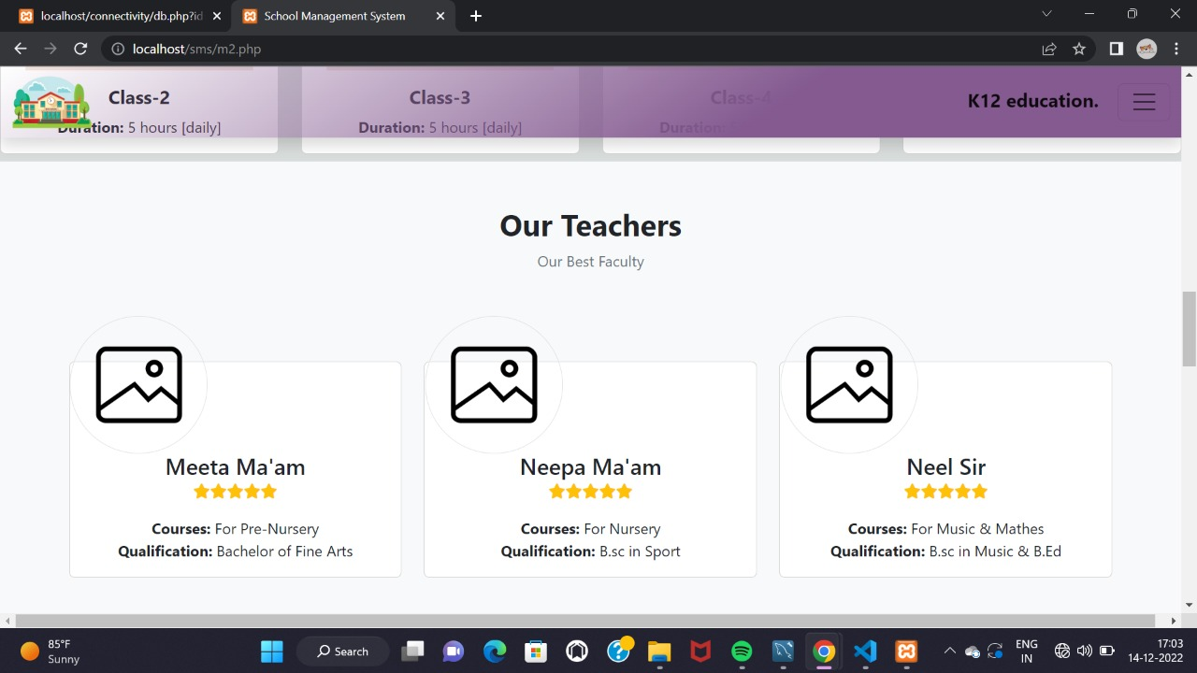

**2nd Home Page**

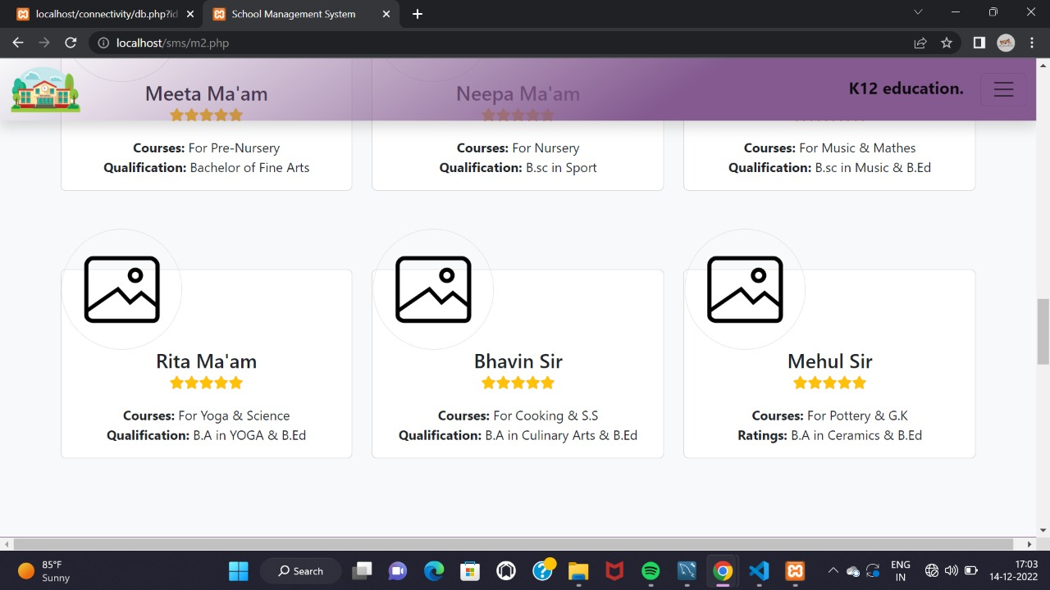

**2nd Home Page**

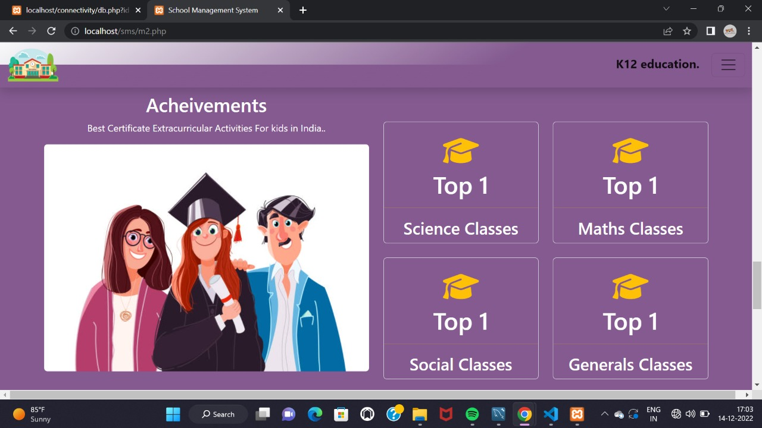

**2nd Home Page**

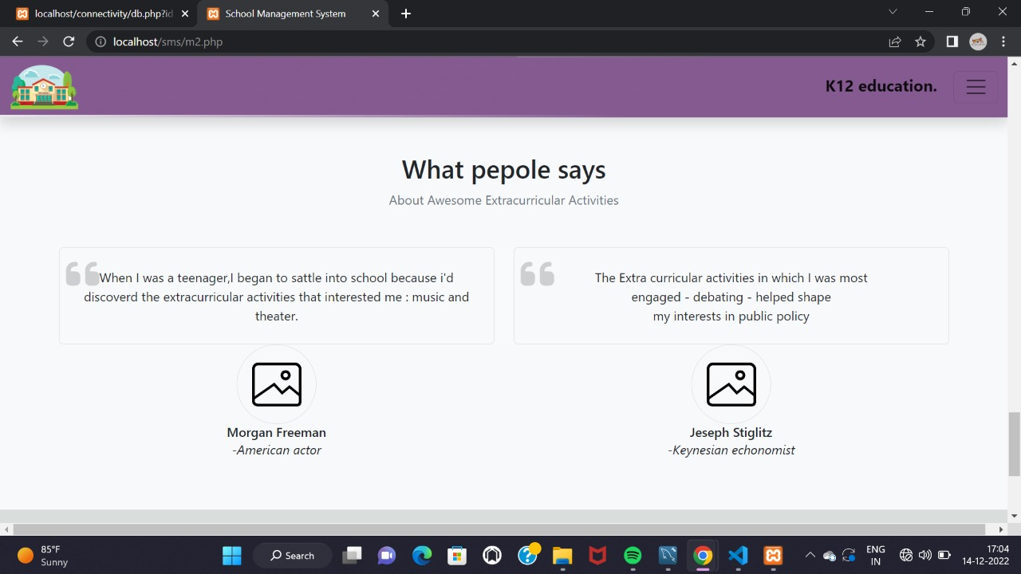

**2nd Home Page**

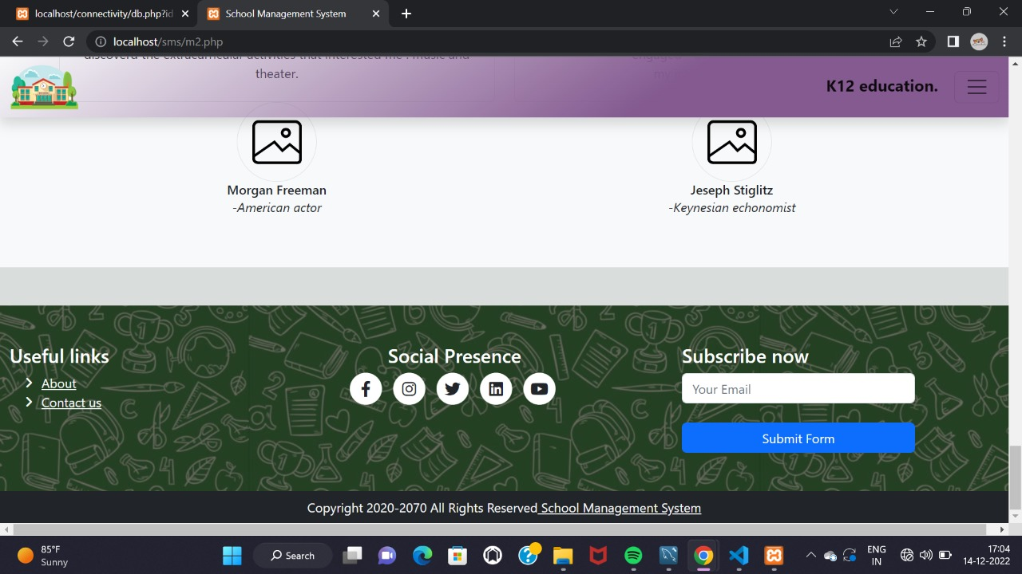

**Admission Form Page**

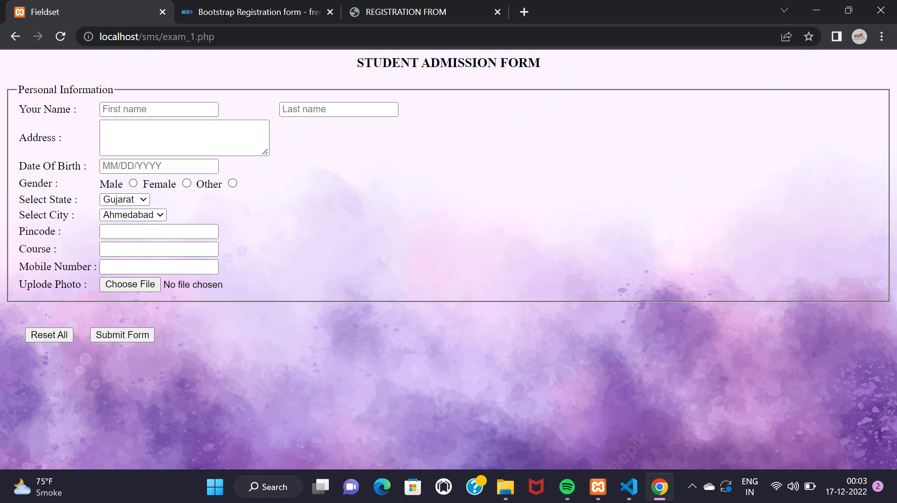

**About Us Page**

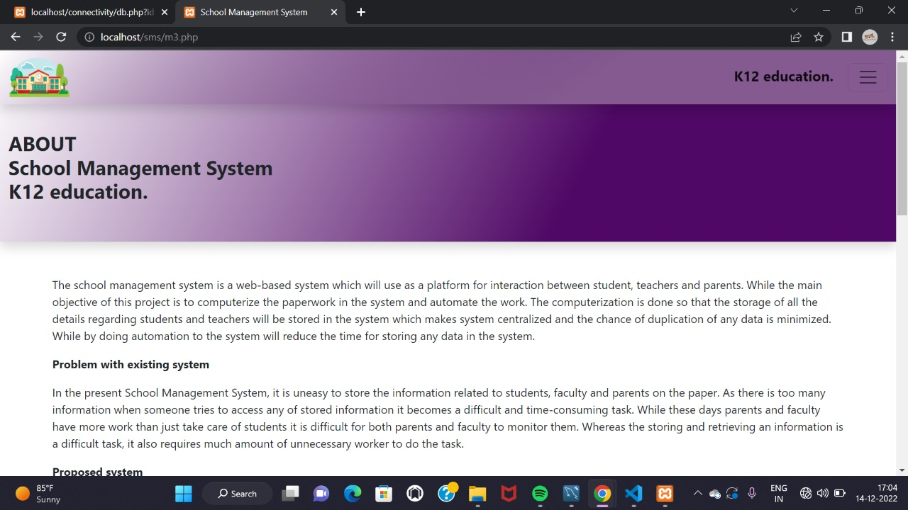

**About Us Page**

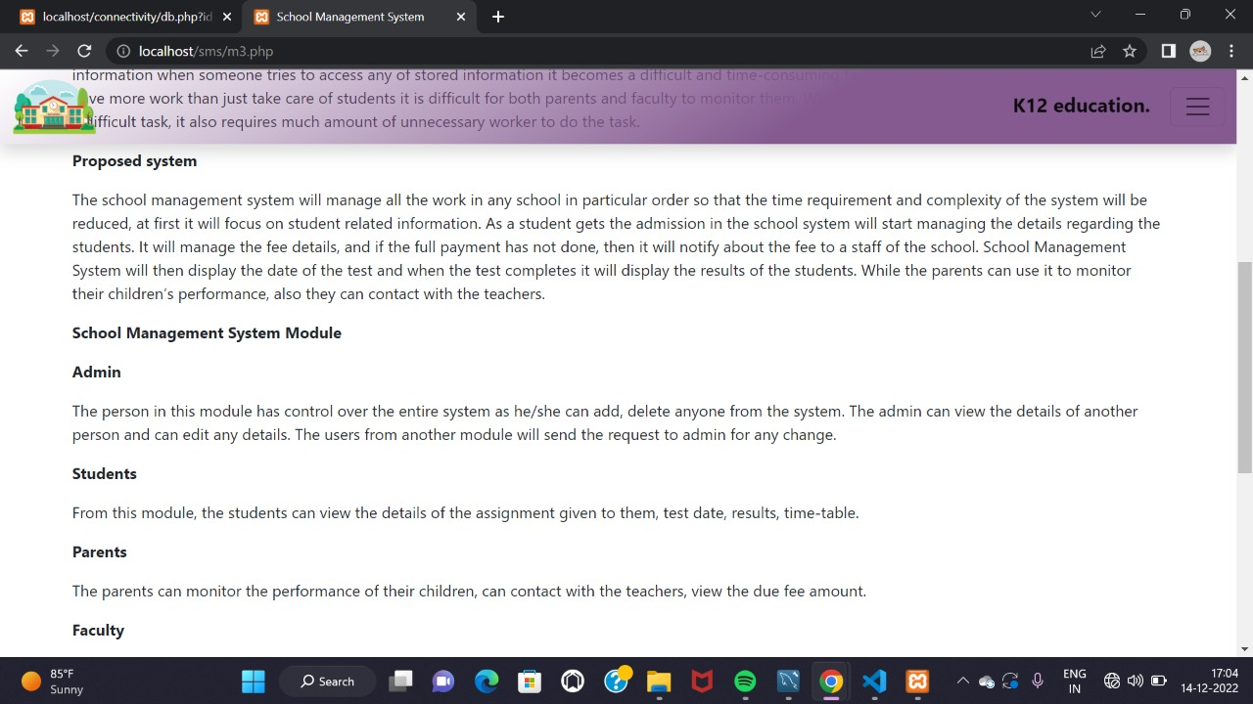

**About Us Page**

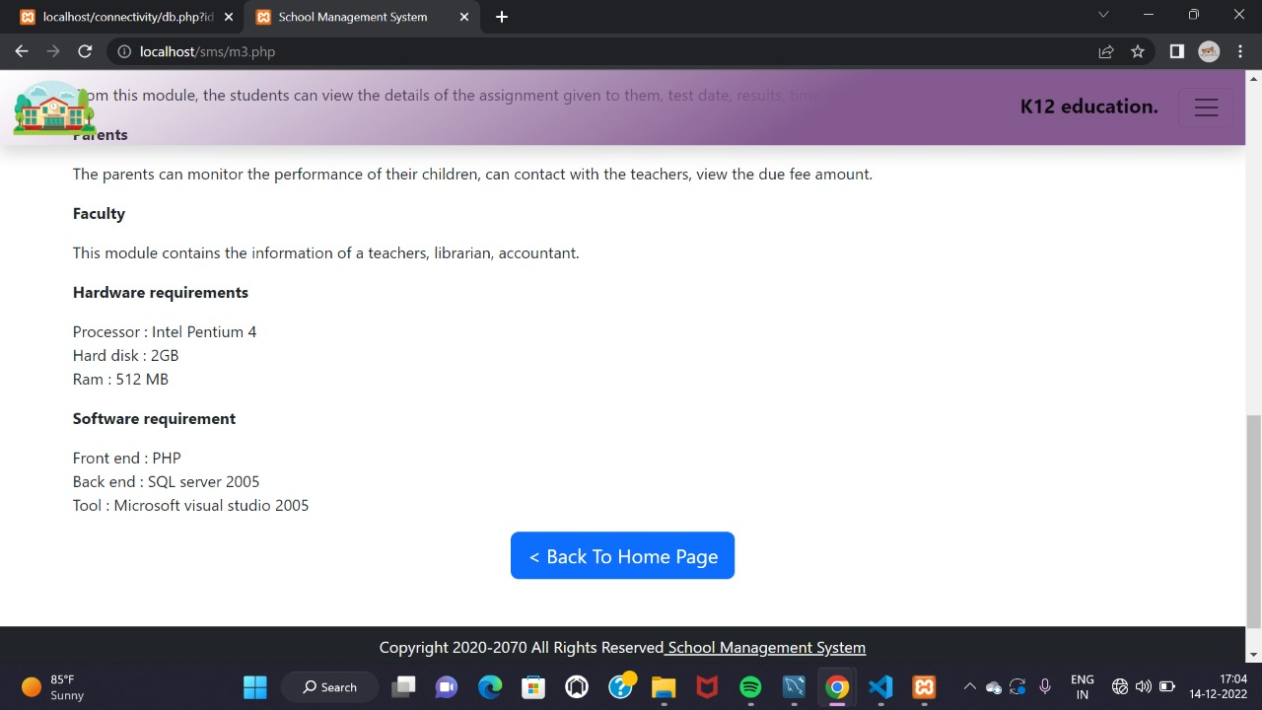

**Contact Us Page**

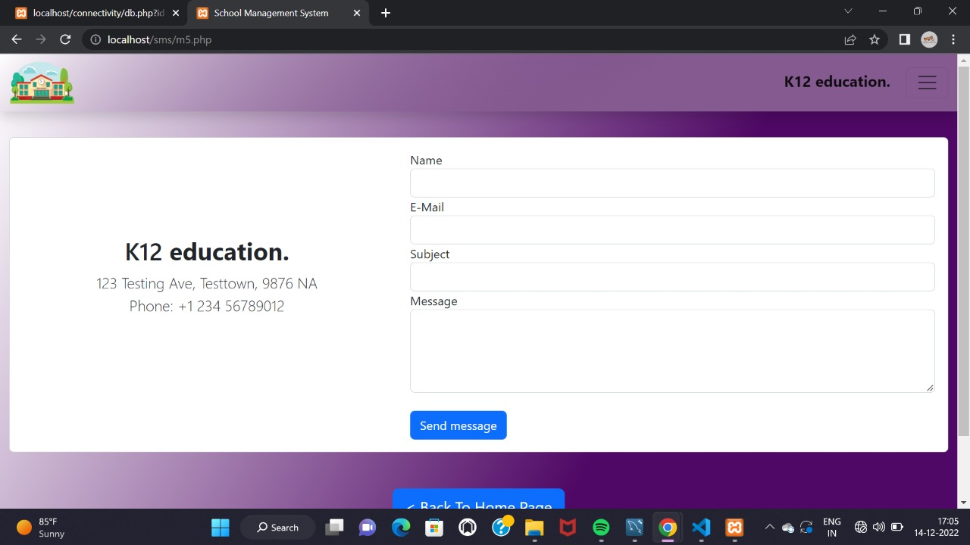

**Admin Page**

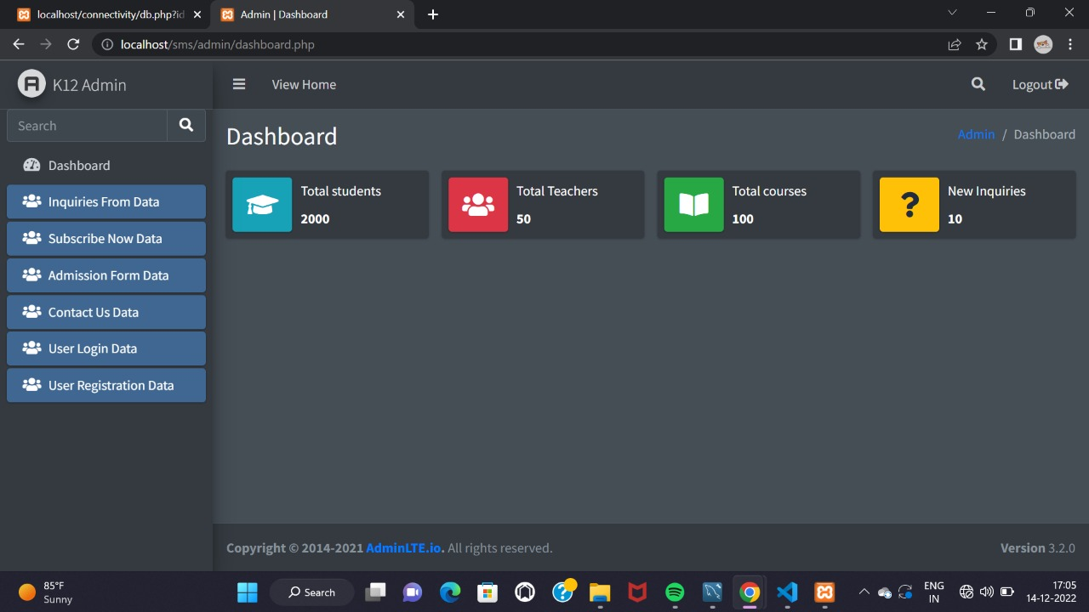

**Classes K12 education**

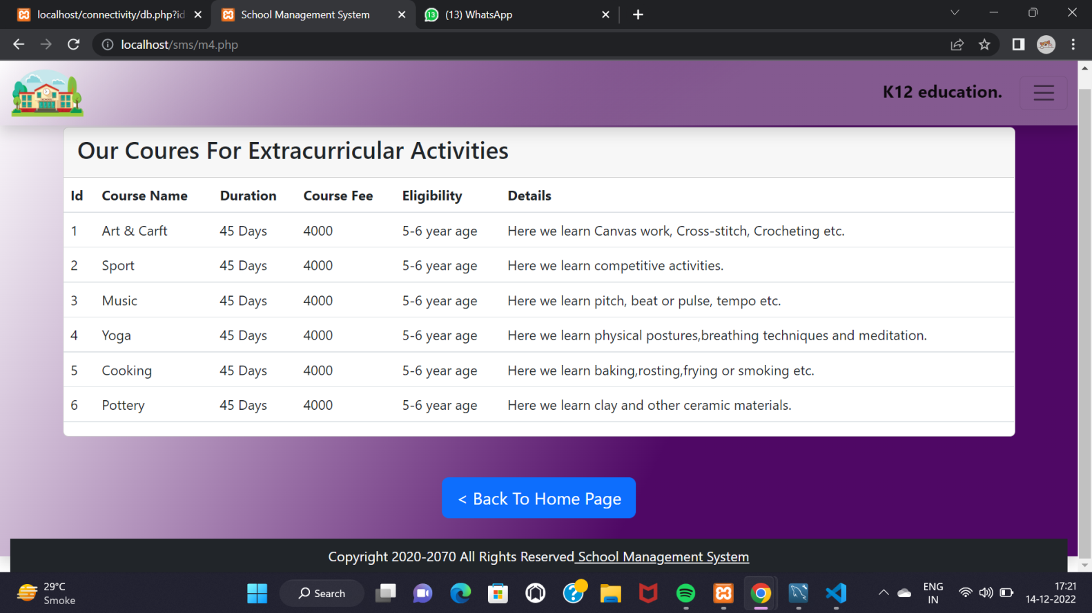

**5. Testing**

* Web Application testing, is a software practice that ensures quality by testing that the functionality of a given web application is working as intended or as per the requirements.
* Web testing checks for functionality, usability, security, compatibility, performance of the web application or website.

**5.1 Test Cases**

|  |  |  |  |  |  |
| --- | --- | --- | --- | --- | --- |
| **No** | **Title** | **Expected Result** | **Actual Result** | **Solution** | **Status** |
| 1. | Home page | Verify all the images and info is displayed and clearly visible | All the information and images are displayed | Done | Success |
| 2. | Login page | Password Should contain special characters and at least 8 characters | Displayed Special Characters were there, Password characters  Were infinite. | Password required minlength=8  Maxlength=12 | Success |
| 3. | Contact Us Page | Check is the name accept valid names. | Check if the user enters an invalid name and then if the warning message is displaying or not. | Done | Success |
| 3. | Admission Page | From navigation bar we can click Admission Page and reach to it’s page. | We can click Admission Page directly from Student’s home page. | Done | Success |
| 5. | About us Page | Check all the field values are displayed on the respective fields of the edit page. | Check the User is able to edit the record by entering the valid data. | Done | Success |
| 6. | Registration Page | Display in Full Screen | Not Displayed in Full Screen, Height, Width is different | Done | Success |
| 7. | Student’s Home Page | Verify all the images and info is displayed and clearly visible | All the information and images are displayed | Execute | Execute |

**6. Conclusion**

* We have identified the concepts of our system and the technologies that have been used with my school.
* Also the related systems and their advantages and disadvantages, and a comparison between our system and the other systems.

**7. Future Enhancement**

* Some ideas features can be considered as a future work for this project.
* In future our requirements are on data binding.
* In future manage all the panels with data.
* In future we will also add some other facility.
* And we had also extended facility that request the user to provide location of the school they want in the particular area.

**8. References and Bibliography**

[WWW.GOOGLE.COM](http://WWW.GOOGLE.COM)

<https://youtu.be/Kv8U84g9520>

<https://projectsgeek.com>